**Data Analysis for Module 9 Challenge**

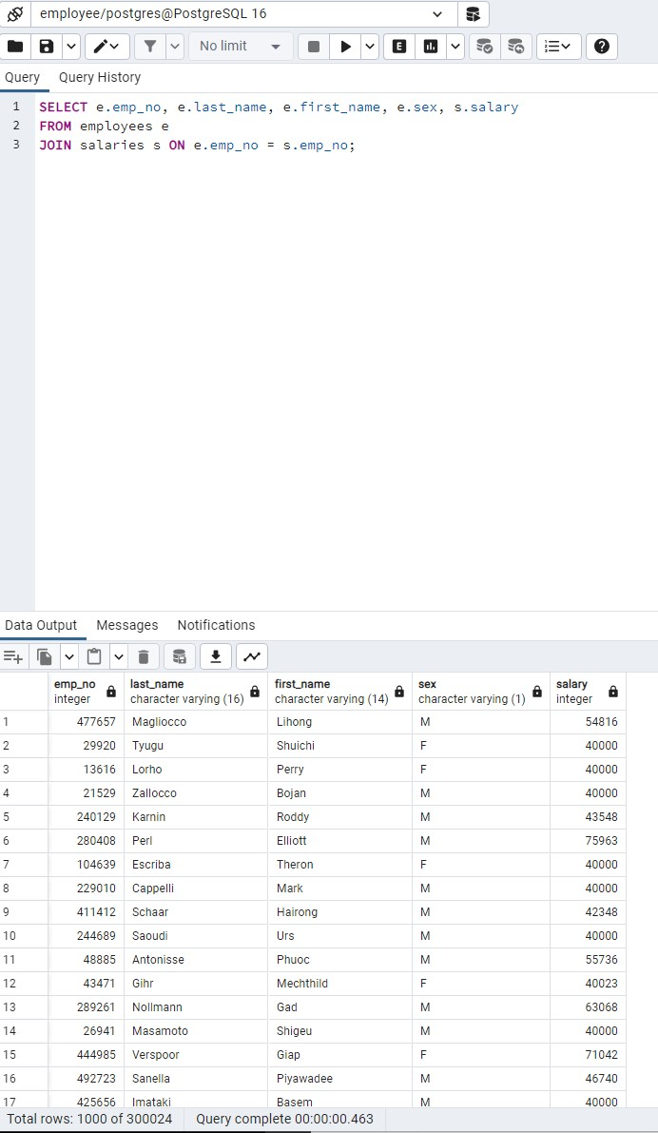I was having trouble exporting the files as CSV as the outputs were massive for some queries so I decided to take a screenshot of the output for each query instead.

1. Employee number, last name, first name and salary of each employee are provided in the screenshot.
2. 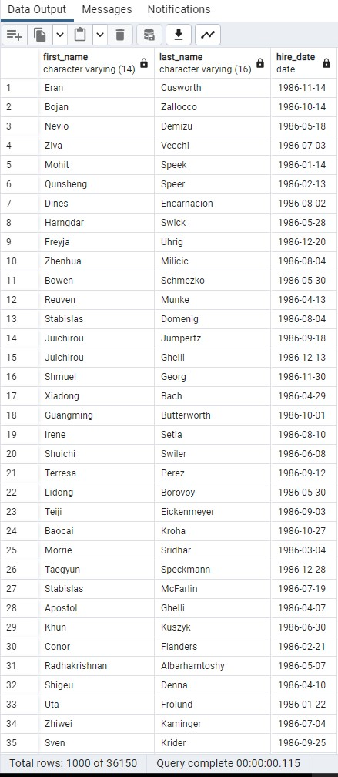First name, last name, and hire date for the employees who were hired in 1986 are provided in the screenshot.

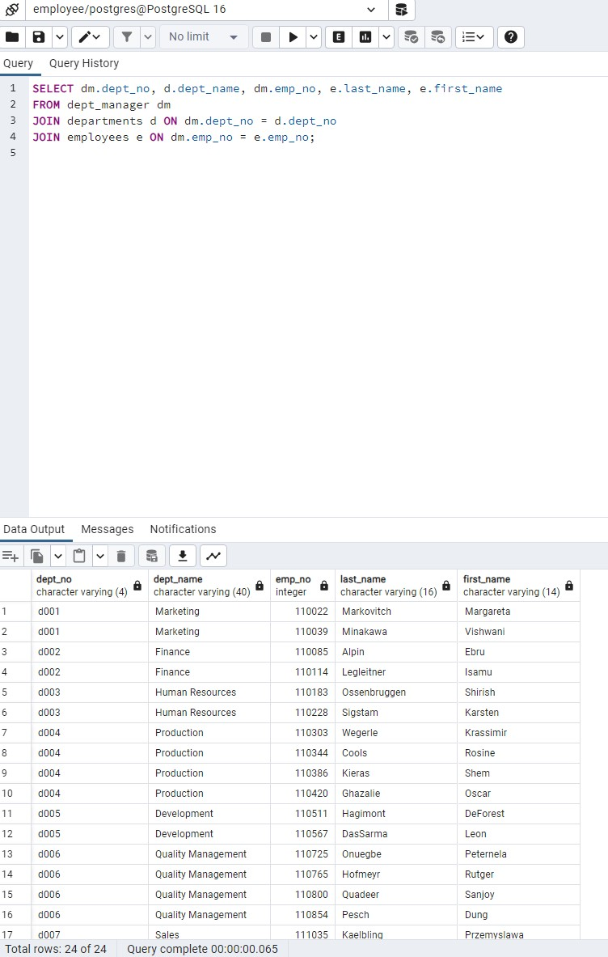

1. The manager of each department along with their department number, department name, employee number, last name, and first name are given in the screenshot.

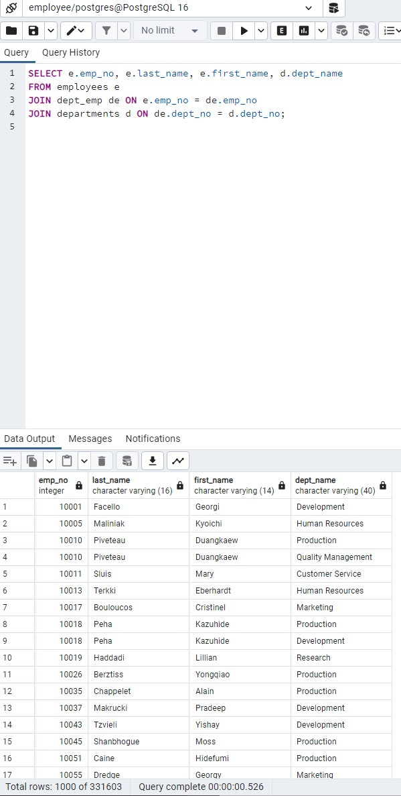

1. The department number for each employee along with that employee’s employee number, last name, first name, and department name are shown in the screenshot.

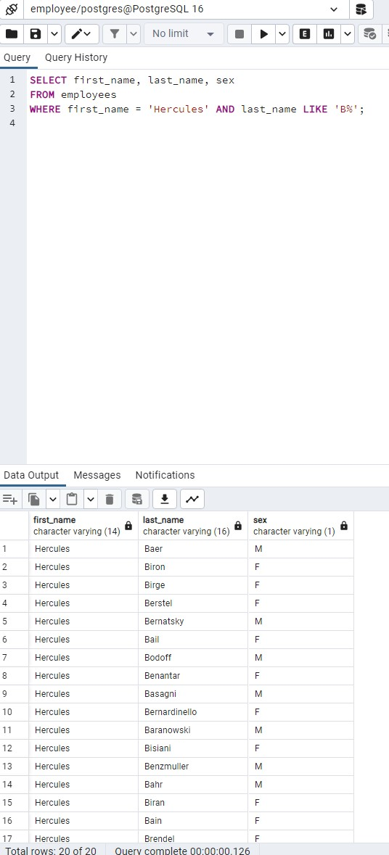

1. A list of the first name, last name, and sex of each employee whose first name is Hercules and whose last name begins with the letter B is displayed in the screenshot.
2. 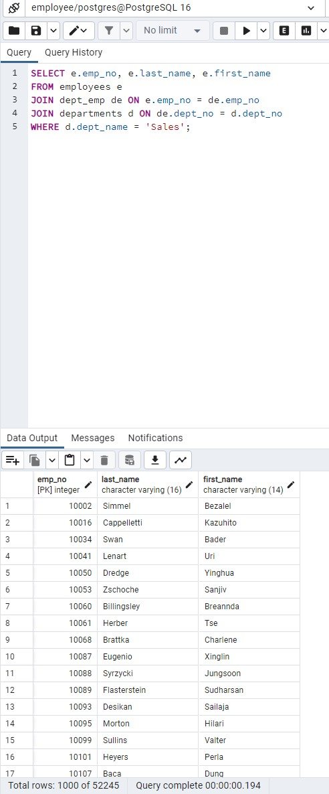A list of each employee in the Sales department, including their employee number, last name, and first name, is displayed in the screenshot.

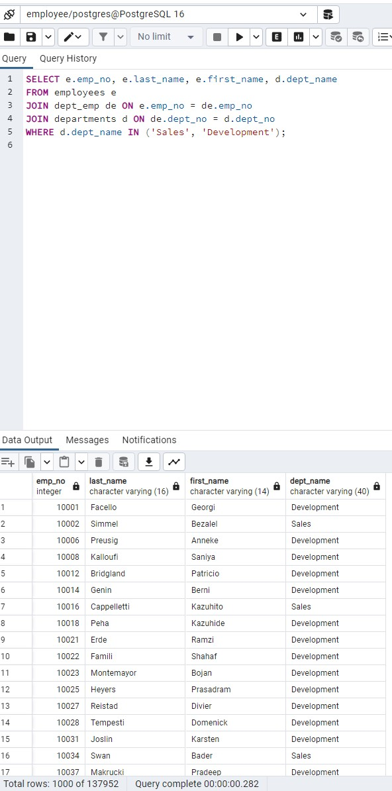

1. A list each employee in the Sales and Development departments, including their employee number, last name, first name, and department name is presented in the screenshot.

1. A List of the frequency counts, in descending order, of all the employee last names (that is, how many employees share each last name) is presented in the screenshot.